Design Assignment #1

# Objective:

Modify the Tristate Bus shown in the figure 1 below. The task is to include 16-bit adder to the design.

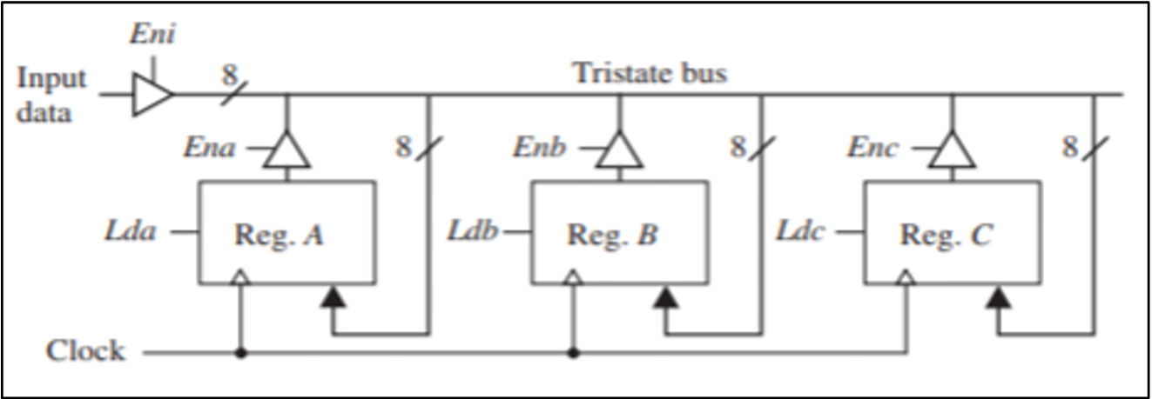

Figure 1: Given Design for Tristate Bus

The adder should perform addition on the contents of the 16-bit registers A and B, storing the result in one of the 16-bit registers:

A, B, C or D.

Additionality, I need to incorporate a fourth register D into the design. The following operations must be performed by the Adders:

* A = B + A
* C = B + D
* D = D + C

# Design: Block Diagram:

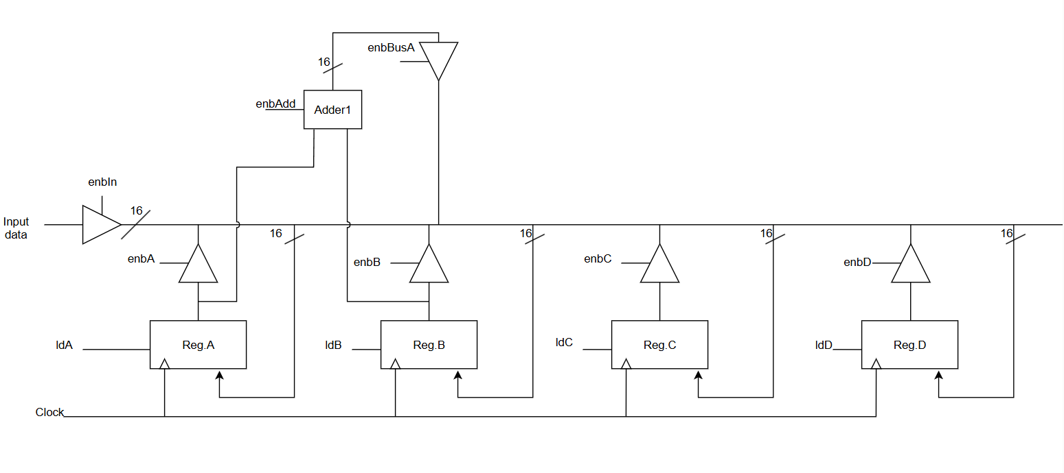

Figure 2: New implemented design with Adder and Fourth Register

Now, in this design. I have implemented all of the required objectives. I have added the fourth register Reg. D and also implemented three Adders for each of the adding Operations. The design is for 16-bit registers and adders.

# Operations:

The following waveform represents all of the three operations, a detail of each operation will follow:

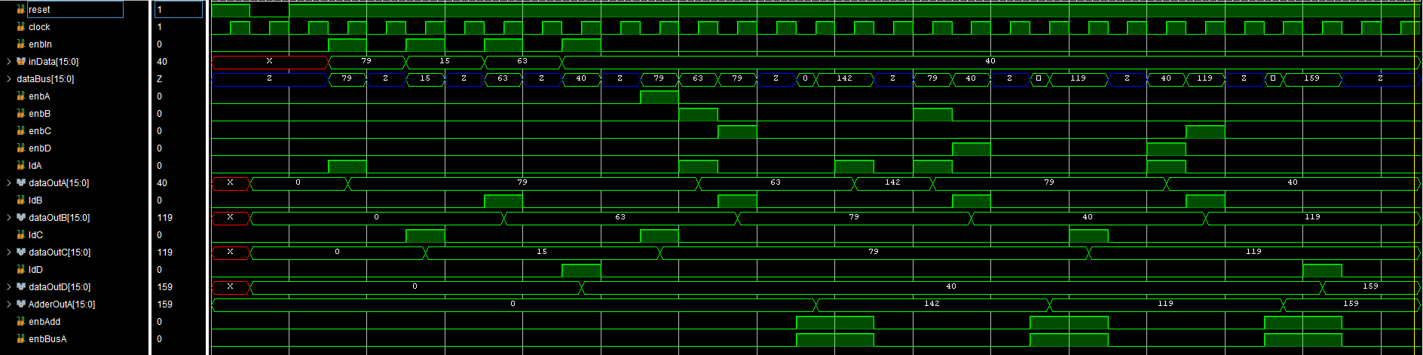

Figure 3: All operations waveform

## Operation: A = B + A

* For this operation, we needed to follow these steps.
* First, we need to shift B data into A and A data into B.
* We first store A data into C register (enbA = 1 and ldC = 1). Then, we store B data into A register (enbB = 1 and ldA = 1).
* Finally, we store A register data now C register data into B register (enbC = 1 and ldB = 1).
* Now, we operate adder to give output (enbAdd = 1 and enbBusA = 1).
* Now, we need to store data into A register so (ldA = 1).
* That concludes operation for A = B + A.
* Here A = 79 and B = 63. After operation we have A = 142. So, that is correct.

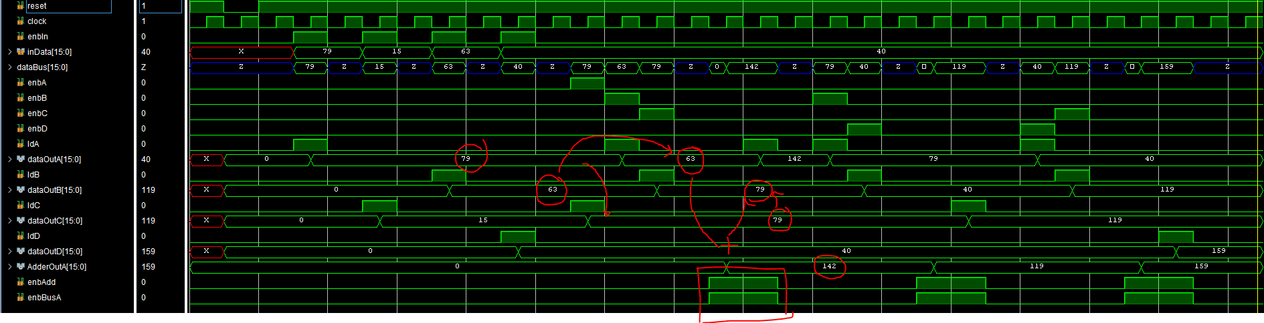

Figure 4: Operation A = B + A

## Operation C = B + D

* For this operation, we needed to follow these steps.
* First, we need to shift B data into A and D data into B.
* We first store B data into A register (enbB = 1 and ldA = 1). Then, we store D data into B register (enbD = 1 and ldB = 1).
* Now, we operate adder to give output (enbAdd = 1 and enbBusA = 1).
* Now, we need to store data into C register so (ldC = 1).
* That concludes operation for C= B + D.
* Here B = 79 and D = 40. After operation we have C = 119. So, that is correct.

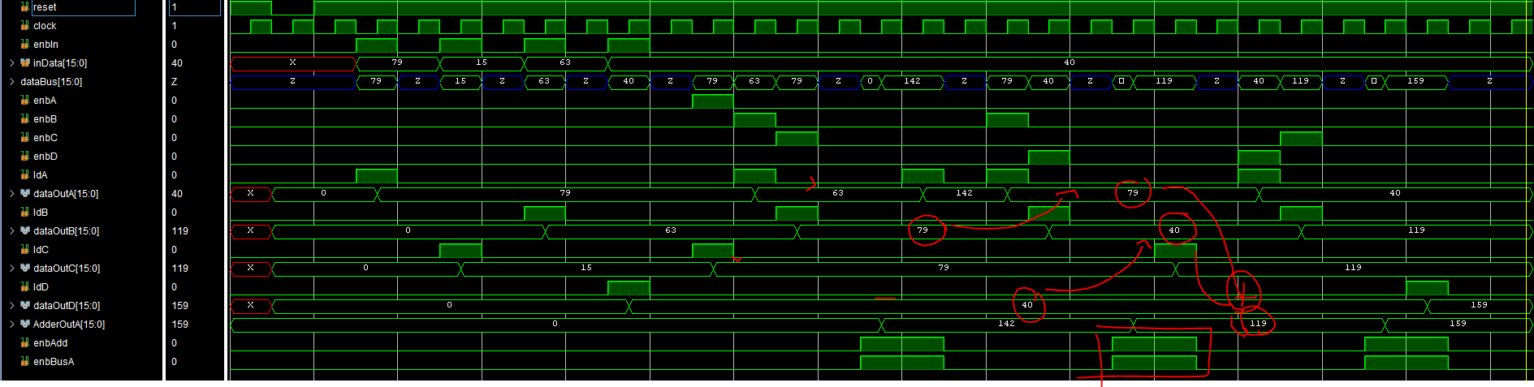

Figure 5: Operation C = B + D

## Operation D = D + C

* For this operation, we needed to follow these steps.
* First, we need to shift D data into A and C data into B.
* We first store D data into A register (enbD = 1 and ldA = 1). Then, we store C data into B register (enbC = 1 and ldB = 1).
* Now, we operate adder to give output (enbAdd = 1 and enbBusA = 1).
* Now, we need to store data into D register so (ldD = 1).
* That concludes operation for D= C + D.
* Here C = 119 and D = 40. After operation we have C = 159. So, that is correct.

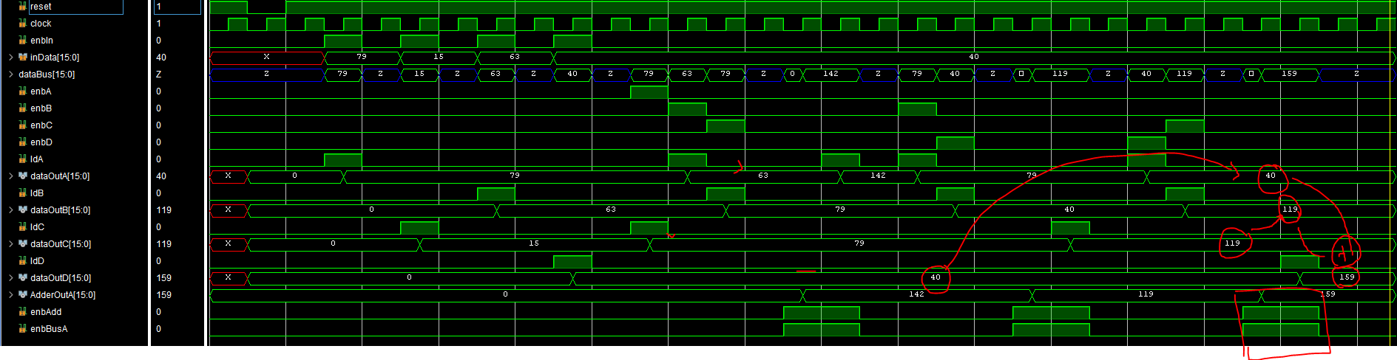

Figure 6: Operation D = C + D

# Conclusion:

All three operations required by the task are completed and verified. The operations are working as intended.